Use this link to : Submit Request
Item  # |  | Item Description | Cost | Date Purchased
1 | 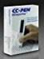 | ReaderPen/C- Pen/Reading Support/Human Reader Alternative/Classroom aid.  Sold by: Scanning Pens Inc | $285.00 | 5/24/2022
2 | 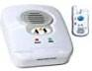 | Medical Alert System for Home Emergency Sold by : Assistive Technology Services | $274.77 | 5/24/2022
3 | 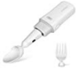 | Gyenno Parkinson Spoon and Fork for hadn tremor. | $268.99 | 5/24/2022
4 | 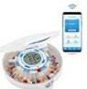 | LiveFine Smart WiFi Automatic Pill dispenser/ 28 Day/Up to 9 doses per day  Sold by DBROTH | $159.83 | 5/24/2022
5 | 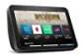 | Echo Show 8  Sold by: Amazon | $99.99 | 5/24/2022
6 | 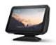 | Echo Show 8 Adjustable Stand  Sold By: Amazon | 22.73 | 5/24/2022
7 |  | Jelly Bean Mechanical Switch | $75.00 | 5/24/2022

8 | 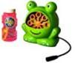 | Switch Adapted Bubble Machine  Sold by LDK Adapted Toys LLC | $54.99 | 5/24/2022
9 | 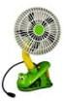 | Switch Adapted Clip on Fan  Sold by: LDK Adapted Toys | $53.99 | 5/24/2022
10 | 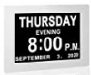 | Digital Calendar Alarm- Day Clock  Sold By: Charger Home | $44.15 | 5/24/2022
11 | 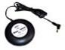 | Shake & Vibrate Bed shaker & Vibrating Alarm | $29.99 | 5/24/2022
12 | 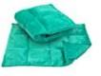 | Little Chubby One Weighted Lap Pad  Sold By: Little Chubby One | $27.95 | 5/24/2022
13 | 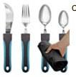 | Bunmo Adaptive Utensils- Weighted  Sold By: Bunmo | $26.99 | 5/24/2022
14 |  | Salmon Sloth Weighted Stuffed Animal Heating Pad  Sold By: D’Mally Co, LLC | $25.99 | 5/24/2022

15 | 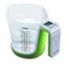 | Digital Kitchen Food Scale and Measuring Cup  Sold By: Kitchen Metrics | $23.98 | 5/24/2022
16 | 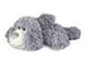 | Weigedu Floppy Puppy Dog Stuffed Animal  Sold By: WEIGEDU | $21.99 | 5/24/2022
17 | 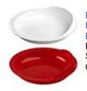 | Providence Spillproof 9 “ Scoop plate/High Low Adaptive Bowl with strong Hold Suction Cup  Sold By: the Stanford Loft | $19.89 | 5/24/2022
18 |  | Shower Handle, 12” Grab Bar for Bathroom  Sold by : Budding Joy | $16.99 | 5/24/2022
19 |  | SP Ableware 745340000 Maddack Ableware Scooper Bowl with Suction base  Sold by: Amazon | $11.59 | 5/24/2022
20 | 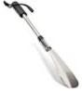 | Long Handled Shoe Lifter | $9.99 | 5/24/2022
21 | 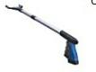 | Grabber Tool, Wide Jaw, Steel cable, 96 Grip points with 32” Magnet.  Sold By: Health Guys | $10.95 | 5/24/2022

22 | 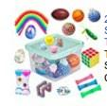 | 24 Pack Bundle Sensory Fidget Toys set  Sensory pack #1  Purchased on: Amazon | $18.99 | 5/24/2022
23 | 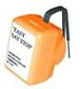 | Easy Say Stop Audible Liquid Level Indicator  Sold By : Maxi-AIDS | $7.95 | 5/24/2022
24 | 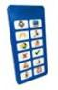 | Tiny Talker  Sold by: Special Needs Essentials | $24.99 | 5/24/2022
25 | 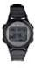 | Watch Minder3- Vibrating Reminder Watch | $78.00 | 05/24/2022
26 | 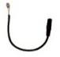 | Battery Interrupter for Adapted Toys Size AA or AAA  Sold by: Enable Solutions | $10.95 | 05/24/2022
27 | 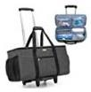 | Luxja Rolling Tote Sold By: AMAZON | $69.99 | 05/24/2022
28 | 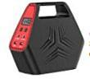 | 146Wh Portable Power Station  Sold By SinKeu US | $84.07 | 6/29/2022

29 |  | BunMo Weighted Utensils for Tremors  Sold By: BunMo | $35.99 | 6/29/2022
30 | 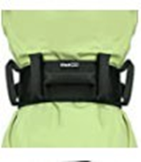 | UKBOO Gait Belt with 7 padded handles  Sold By: UKBOO | $13.99 | 6/29/2022
31 | 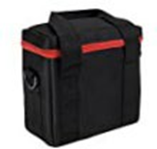 | SinKeu Travel Carrying Case Storage Bag for Portable Power Station  Sold By: SinKeu US | $10.92 | 06/29/2022
32 | 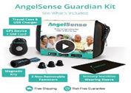 | AngelSense Guardian Kit Wearable Accessories (Belt, Undershirt, watch Band) | KIT-  $119.00  Annual Data  $399.96 | 08/02/2022
33 | 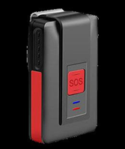 | Geocomm Pendant- 2- way communication device.  SAFE in Home | Monthly Cost:  $43.17 | 10/24/2022
34 | 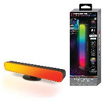 | Monster Smart RGBW IC Light Bar.  Purchased From: Walmart | $14.88 | 10/1/2022
35 | 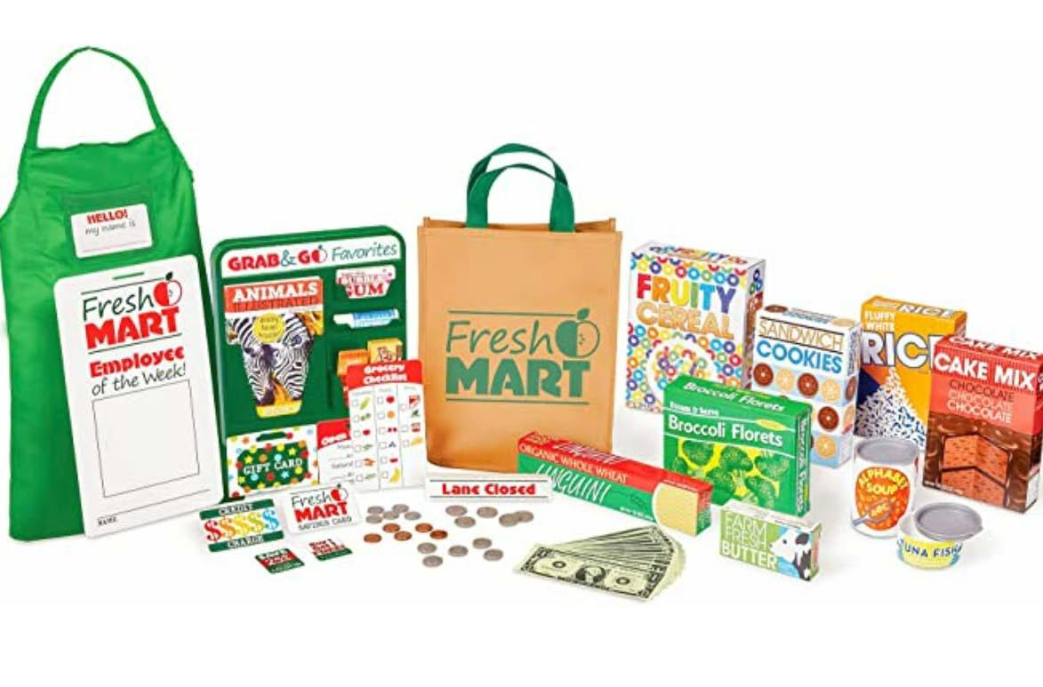 | Melissa & Doug Fresh Mart Grocery Store Play Food and Role Play.  Purchased From:  Amazon | $24.32 | 01/24/2023
36 | 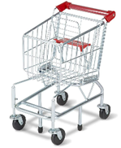 | Melissa & Doug Toy Shopping Cart With Sturdy Metal Frame.  Purchased From:  Amazon | $84.99 | 01/24/2023
37 | 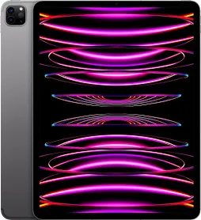 | IPAD  County Board
38 | 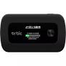 | HotSpot  Purchased from Verizon | 79.99 (Full purchase Price)
39 | 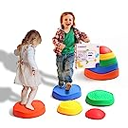 | Makarci Stepping Stones for Kids, Non slip plastic balance River Stones for promoting coordination skills.  Purchased from: Amazon | 39.99 | 08/11/2023
40 | 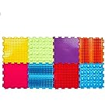 | Massage Sensory Mat Module Game and Adult Orthopedic Massage Puzzle, Floor Mat.  Purchased from:  Amazon | 59.99 | 08/11/2023
41 |  | Massage Sensory Mat Module Game and Adult Orthopedic Massage Puzzle, Floor Mat  Purchased from:  Amazon | 59.99 | 08/11/2023
42 | 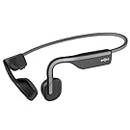 | SHOKZ OpenMove - Open-Ear Bluetooth Sport Headphones - Bone Conduction Wireless Earphones  Purchased from: Amazon | 79.95 | 6/5/2023
43 | 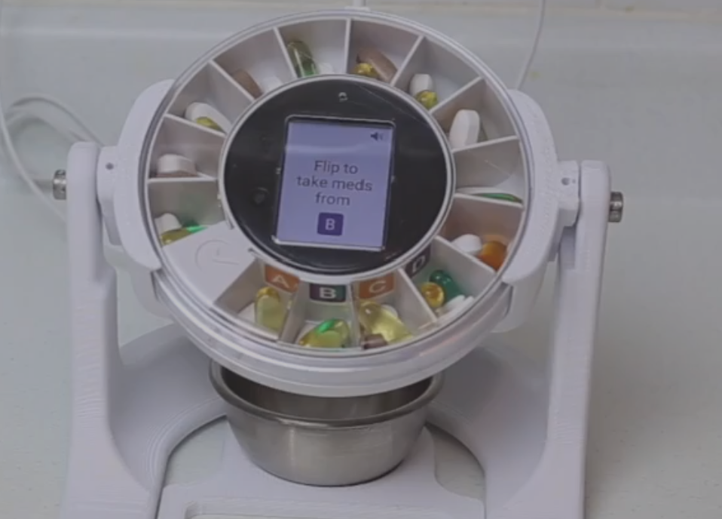 | Dose Flip - Medication Dispenser  Donated by Dose Health
44 | 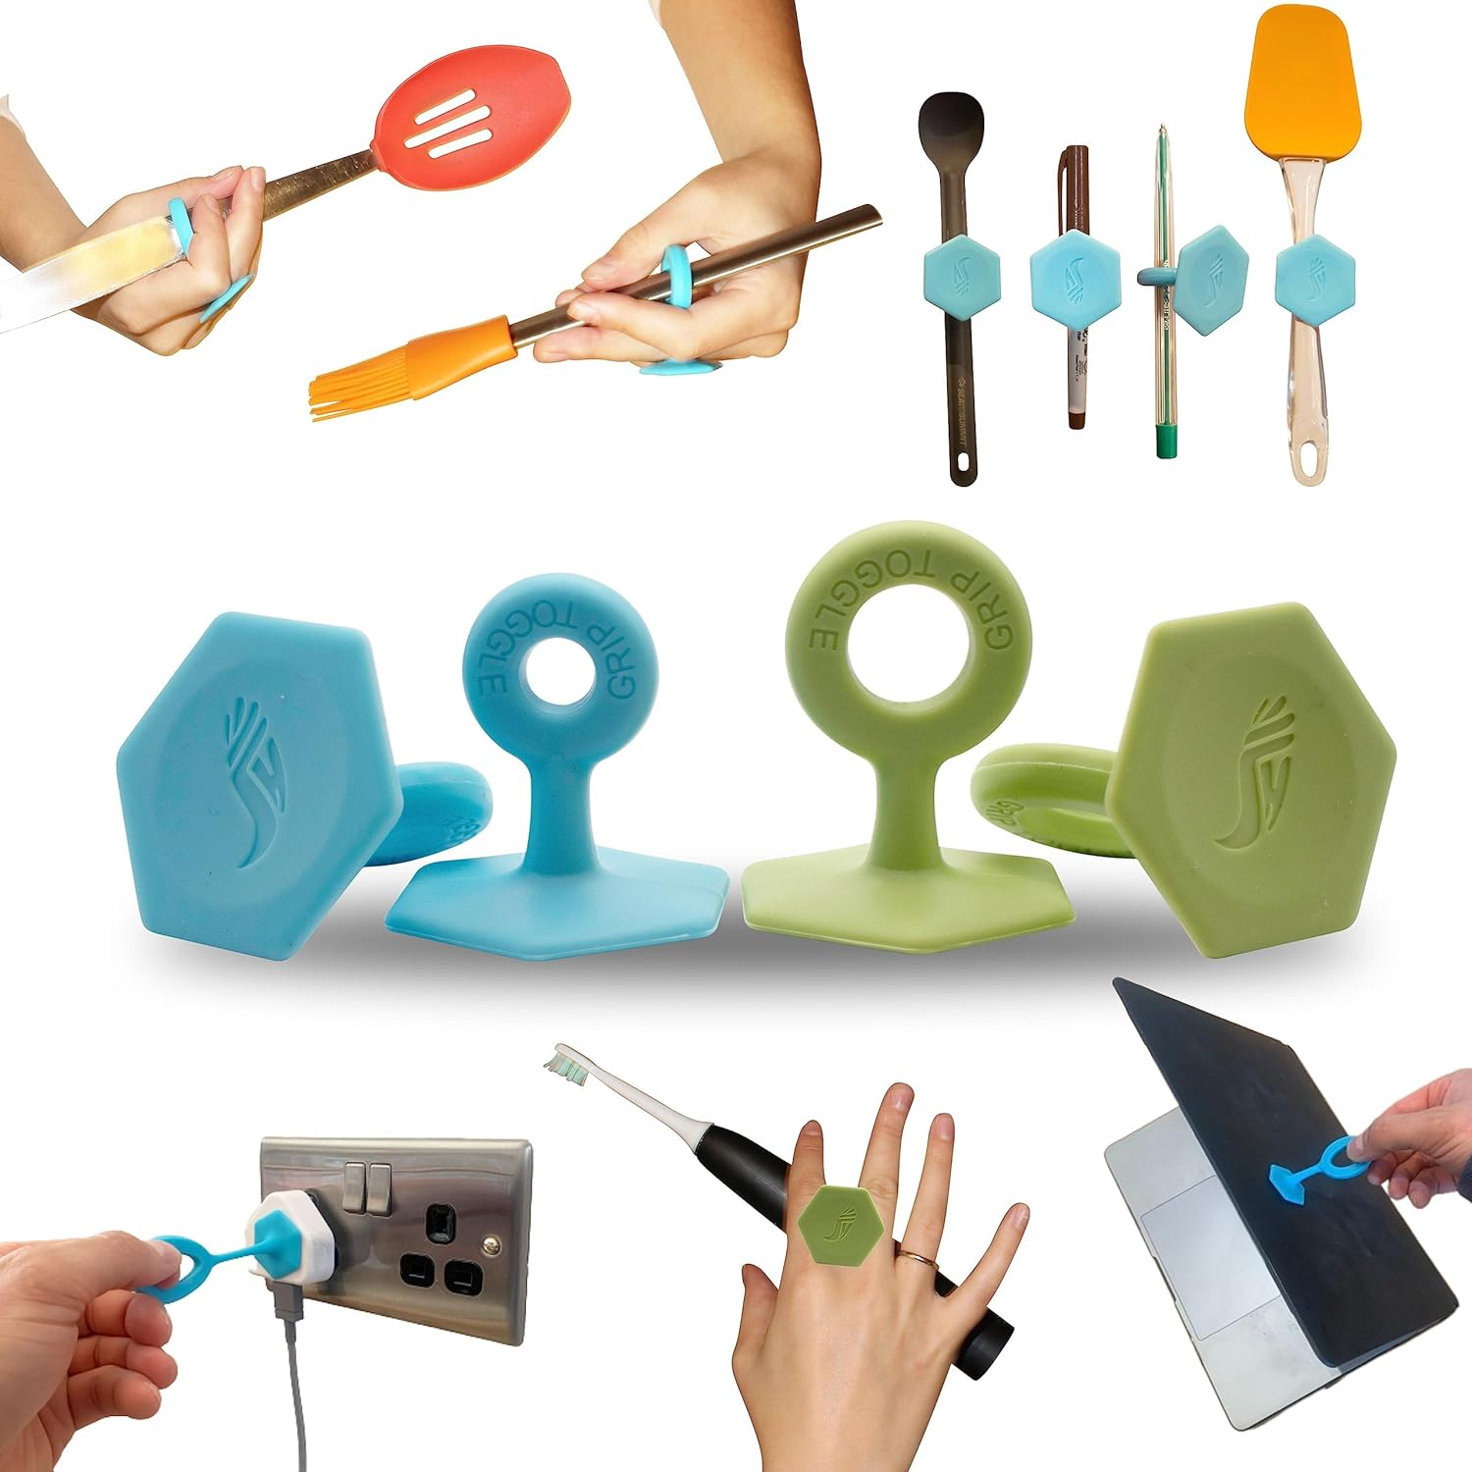 | Grip Toggle-Essential Adaptive Aid for Limited Hand Ability.  Purchase from :Amazon | $19.45 | 1/22/24
45 |  | Liquid Motion Bubbler for Sensory Play  Sensory Pack #2  Purchased from: Amazon | 10 Pack- $33.99 | 1/22/2024
46 | 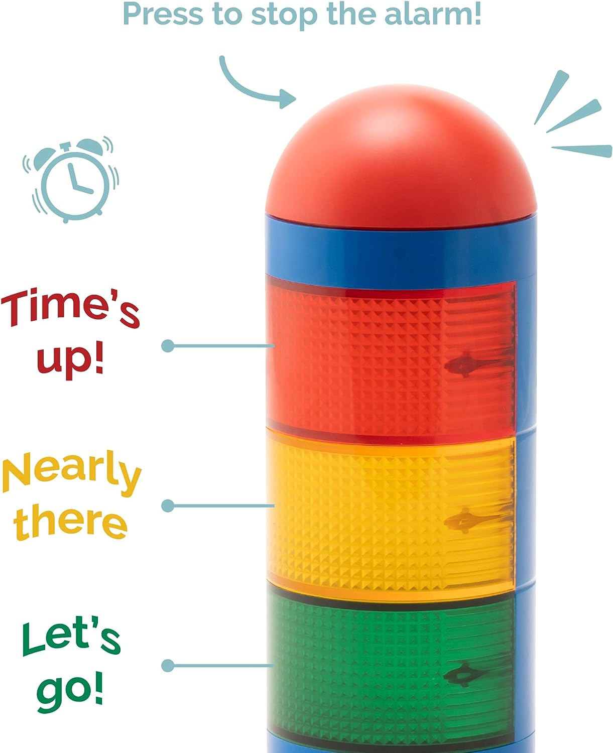 | KADAMS Visual Timer for Kids with Audio Pre-Alarm Traffic Light.  Purchased from: Amazon | $33.29 | 1/22/24
47 | 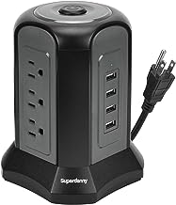 | Power Strip Tower Surge Protector, Super Danny.  Purchased from: Amazon | $25.89 | 1/22/24
48 | 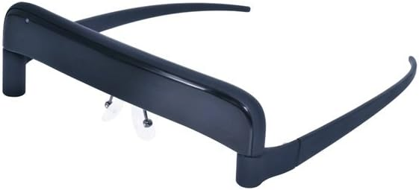 | Glassouse V1.4 Wireless Bluetooth wearable hands free mouse.  Purchased from: Amazon | $580.77 | 1/22/2024

49 | 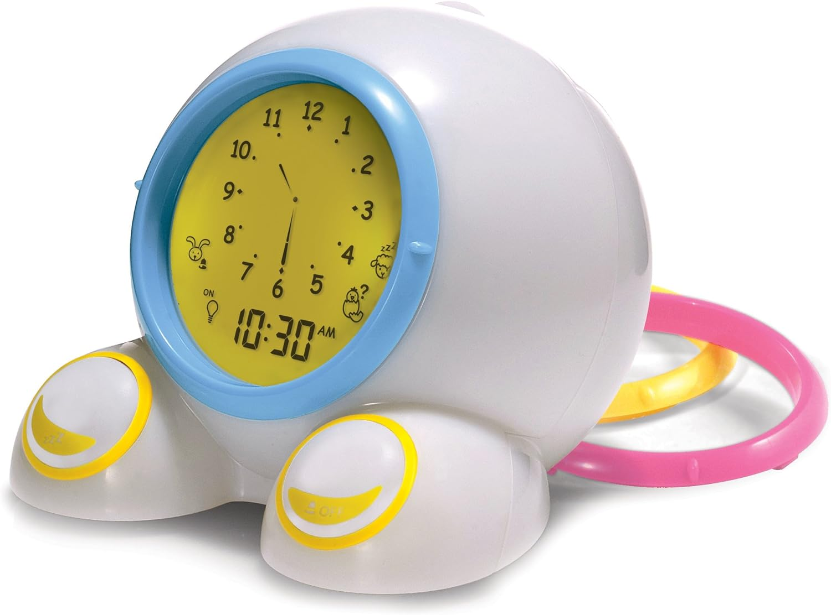 | PalyMonster Teach me Time Educational Alarm Clock & Night Light.  Purchased:Amazon  Sold By: Balkowitsch Enterprises | $54.99 | 1/22/2024
50 | 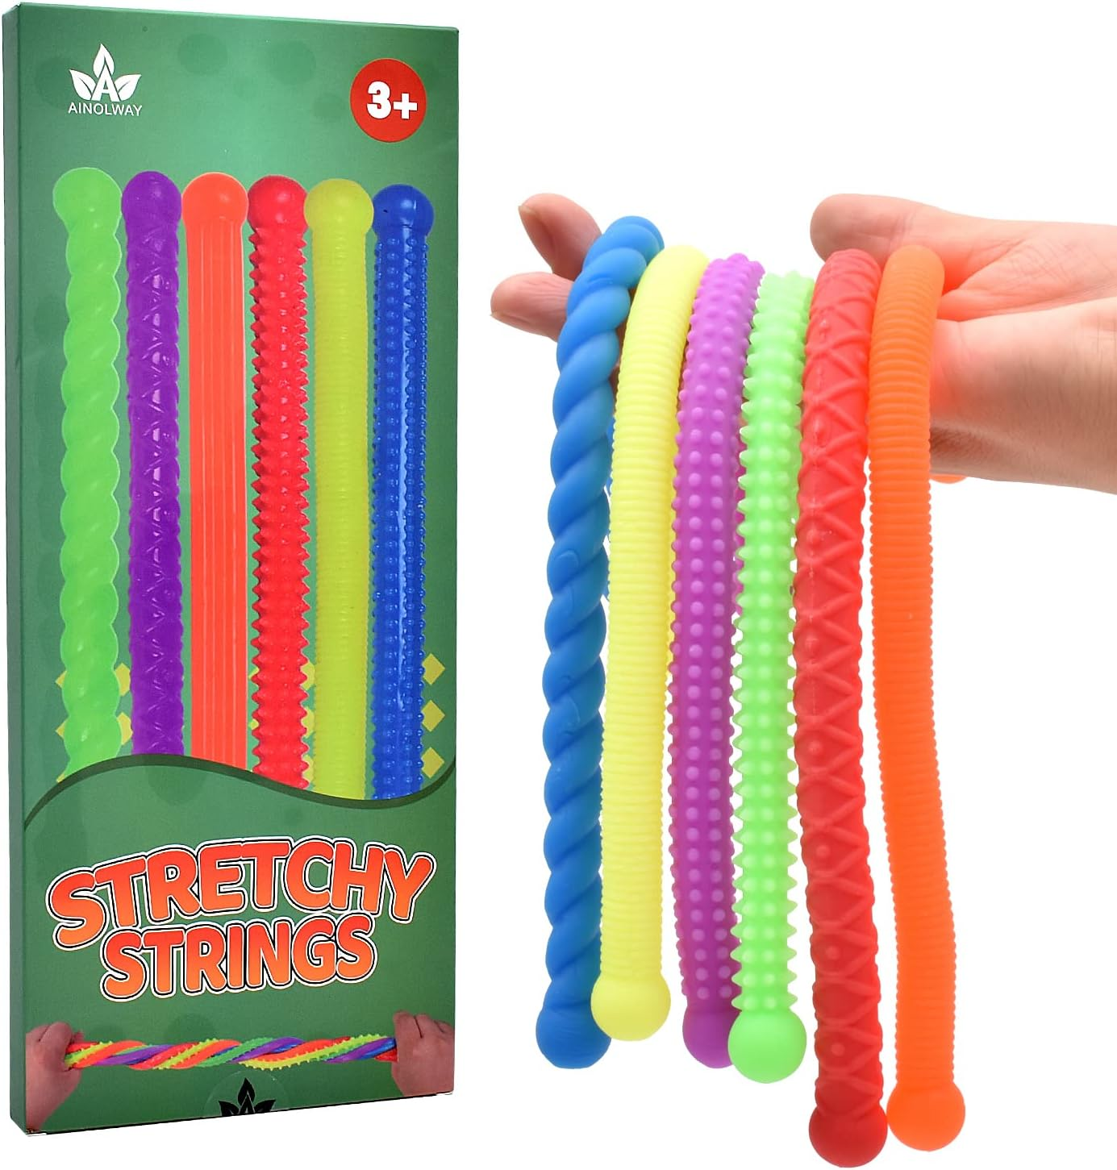 | Super Sensory Stretchy Strings 6 Pk  Sensory Pack #3  Purchased on: Amazon  Sold by; BunMo | $9.99 | 1/22/2024
51 | 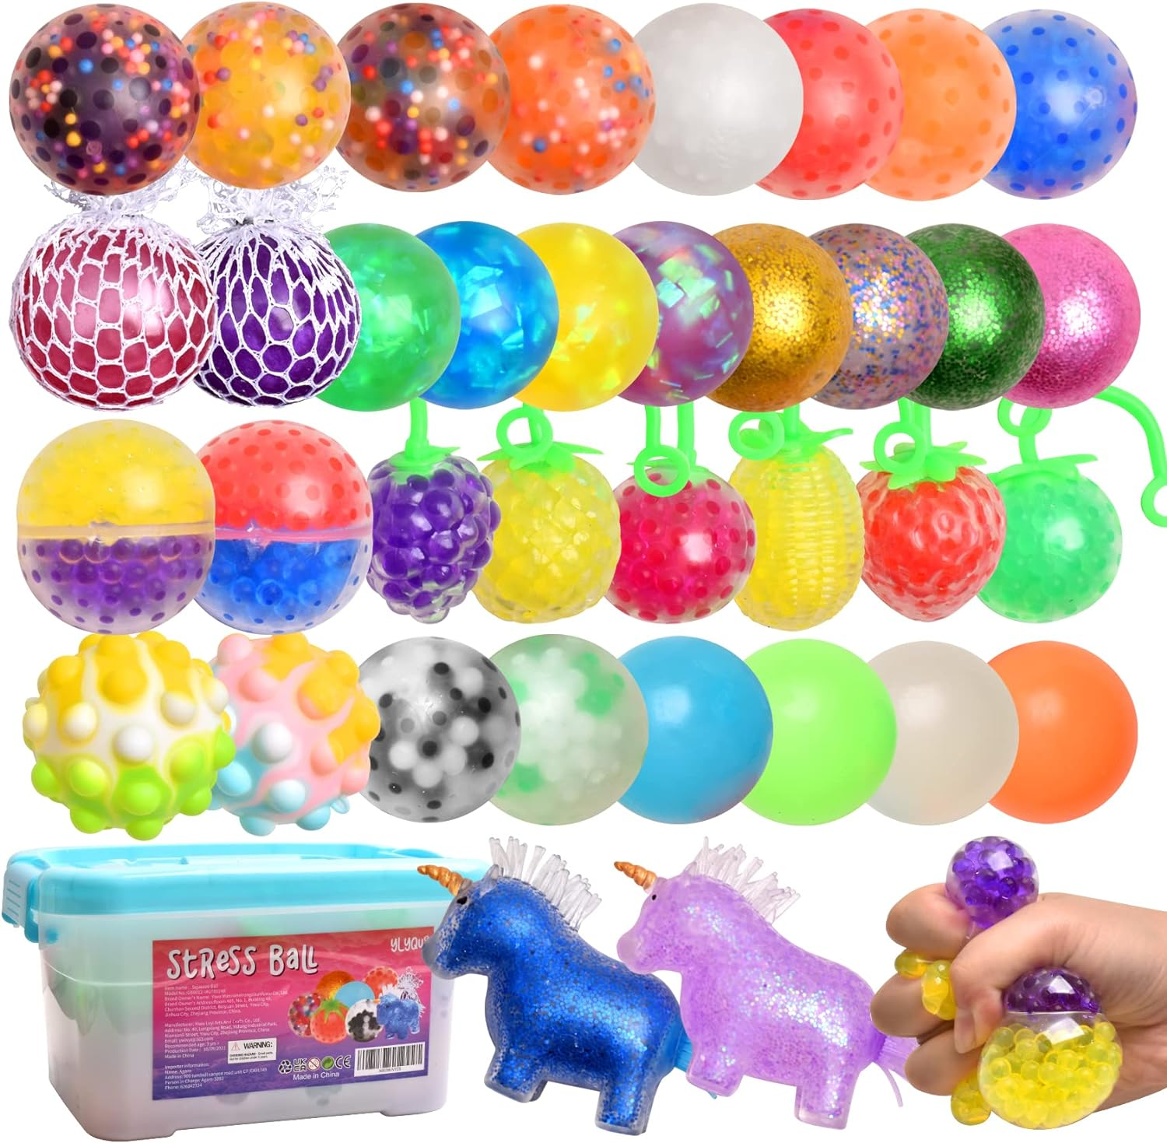 | Stress balls, Squishy Balls, Fidget toys.  Sensory Pack #4  Purchased on: Amazon | $35.99 | 1/22/24
52 | 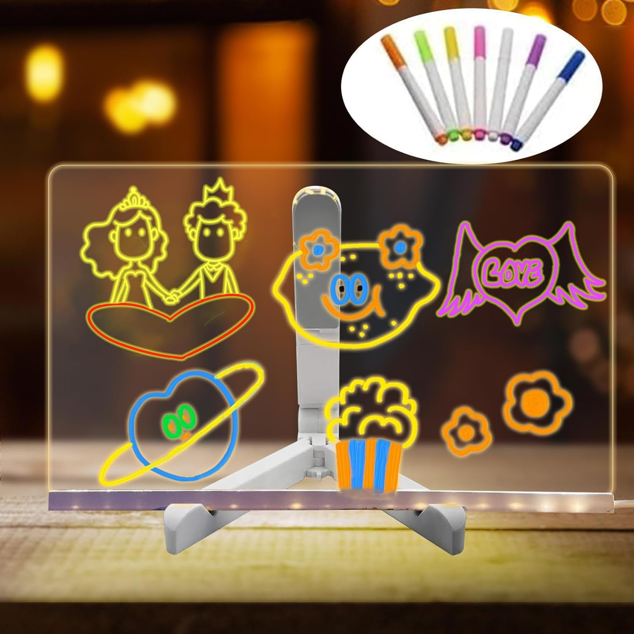 | LED Note Board with Colors, Dry Erase Board with Light.  Purchased on: Amazon | $14.30 | 1/22/24
53 | 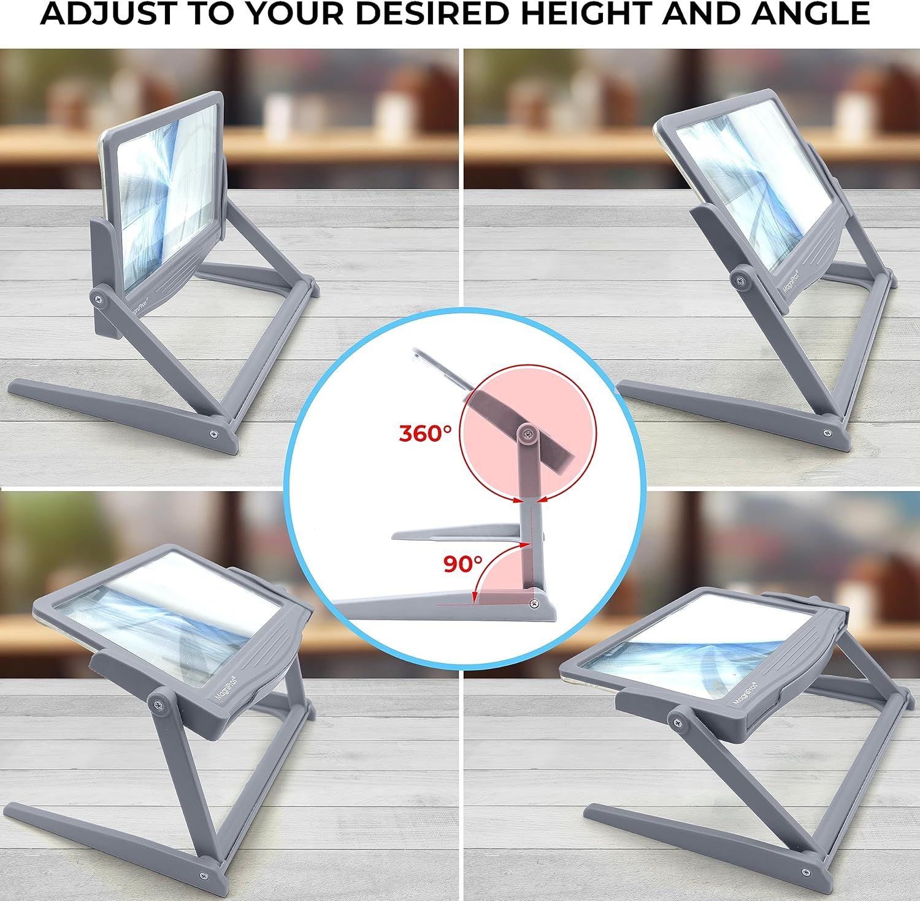 | MAGNIPROS 5X Large LED Hands-Free full page magnifying Glass with Stand.  Purchased on: Amazon  Sold by: LivingLife | $23.95 | 1/22/24

